**Hospitality Domain Data Analysis Project**

Overview

As part of a monthly challenge run by Codebasics, I took on a project involving AtliQ Grands, a fictional luxury hotel chain experiencing a decline in market share and revenue. My goal was to use data analysis to uncover insights that could aid in their decision-making process.

The Challenge

My objectives were:

1. Developing metrics based on a provided list.
2. Creating a dashboard aligned with stakeholders' mock-ups.
3. Generating additional relevant insights not included in the initial metrics or mock-ups.

About AtliQ Grands

* **Operations:** In 4 cities across India.
* **Properties:** 7 in total, each in these cities.
* **Room Categories:** Elite, Premium, Presidential, Standard.
* **Booking Platforms:** Primarily 6 main platforms, among others.

Data Utilized

* **dim_date:** Dates, week numbers, day types.
* **dim_hotels:** Property ID, name, category, cities.
* **dim_rooms:** Room ID, class.
* **fact_aggregated_bookings:** Booking details like property ID, dates, room category, successful bookings, capacity.
* **fact_bookings:** Additional financial data such as booking ID, dates, number of guests, room category, booking platform, ratings, booking status, and revenue.

My Approach

* Implemented a star schema for data modeling.
* Cleaned data, especially in the **dim_date & fact_aggregated_bookings** table, using DAX formulas.
* Calculated KPI’s which are not directly.

Report Highlights

* **Financial Stats**: Key metrics like revenue, RevPAR (Revenue per Available Room), and ADR (Average Daily Rate).
* **Performance Metrics**: Metrics such as Daily Sellable Room Nights (DSRN), Daily Booked Room Nights (DBRN), Daily Utilized Room Nights (DURN), cancellation percentage, average rating, and more.

Filters Applied

* **Week Number:** To analyze weekly performance.
* **Month:** For assessing monthly trends.
* **Property:** To understand each property's impact.
* **City:** To gauge market value in different locations.
* **Room Class:** To identify issues and opportunities in different room categories.
* **Booking Platforms:** To understand customer booking preferences and target marketing efforts effectively.

[**Interactive Dashboard**](https://app.powerbi.com/view?r=eyJrIjoiNDU0YThmZWQtMjAzZS00ZDJkLWI5OTEtYmIyYmVhMWIzZmMyIiwidCI6ImM2ZTU0OWIzLTVmNDUtNDAzMi1hYWU5LWQ0MjQ0ZGM1YjJjNCJ9)

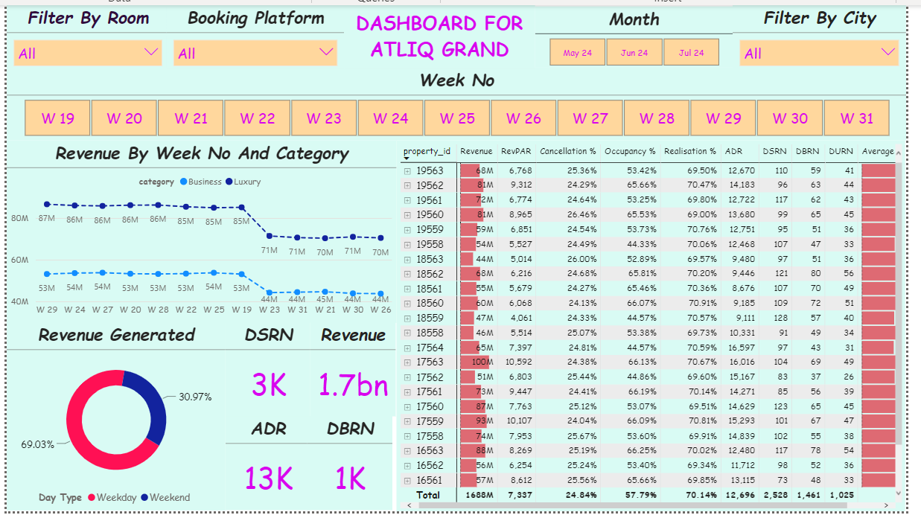

**Key Insights**

**Financial Performance by Hotels**: Found disparities in revenue, RevPAR, and ADR among different hotels.

|  |  |  |  |
| --- | --- | --- | --- |
| Performance | | Name | Value |
| Revenue | Highest | AtliQ Exotica | 320M |
| Lowest | AtliQSeasons | 66M |
|  |  |  |  |
| RevPAR | Highest | AtliQ Exotica | 7.8k |
| Lowest | AtliQ Grands | 6.5k |
|  |  |  |  |
| ADR | Highest | AtliQ Seasons | 16.6k |
| Lowest | AtliQ Blu | 11.9k |

**By Room Class**: Noted revenue and rate differences across room categories.

|  |  |  |  |
| --- | --- | --- | --- |
| Performance | | Name | Value |
| Revenue | Highest | Elite | 560M |
| Lowest | Standard | 310M |
|  |  |  |  |
| RevPAR | Highest | Presidential | 13.7k |
| Lowest | Standard | 4.7k |
|  |  |  |  |
| ADR | Highest | Presidential | 23.4k |
| Lowest | Standard | 8.1k |

**By City**: Mumbai topped in revenue, RevPAR, and ADR, while Delhi and Hyderabad lagged.

|  |  |  |  |
| --- | --- | --- | --- |
| Performance | | Name | Value |
| Revenue | Highest | Mumbai | 668.6M |
| Lowest | Delhi | 294.5M |
|  |  |  |  |
| RevPAR | Highest | Mumbai | 8.9k |
| Lowest | Hyderabad | 5.4k |
|  |  |  |  |
| ADR | Highest | Mumbai | 15.4k |
| Lowest | Hyderabad | 9.3k |

This report aims to clearly present my analysis and findings, providing actionable insights for AtliQ Grands to enhance their decision-making processes.

**Abbreviations of Metrics**

|  |  |
| --- | --- |
| Realization | Utilized Room Nights / Booked Room Nights |
| RevPAR | Revenue Per Available Room |
| ADR | Average Daily Rate |
| DBRN | Daily Booked Room Nights |
| DSRN | Daily Sellable Room Nights |
| DURN | Daily Utilized Room Nights |
| Revenue WoW change % | Revenue Week Over Week Change |

**Kye Measures Created**

|  |  |  |
| --- | --- | --- |
| 1 | Revenue | = SUM(fact_bookings[revenue_realized]) |
| 2 | Total Bookings | = COUNT(fact_bookings[booking_id]) |
| 3 | Total Capacity | = SUM(fact_aggregated_bookings[capacity]) |
| 4 | Total Succesful Bookings | Total Succesful Bookings = SUM(fact_aggregated_bookings[successful_bookings]) |
| 5 | Occupancy % | = DIVIDE([Total Succesful Bookings],[Total Capacity],0) |
| 6 | Average Rating | = AVERAGE(fact_bookings[ratings_given]) |
| 7 | No of days | = DATEDIFF(MIN(dim_date[date]),MAX(dim_date[date]),DAY) +1 |
| 8 | Total cancelled bookings | = CALCULATE([Total Bookings],fact_bookings[booking_status]=”Cancelled”) |
| 9 | Cancellation % | = DIVIDE([Total cancelled bookings],[Total Bookings]) |
| 10 | Total Checked Out | = CALCULATE([Total Bookings],fact_bookings[booking_status]=”Checked Out”) |
| 11 | Total no show bookings | = CALCULATE([Total Bookings],fact_bookings[booking_status]=”No Show”) |
| 12 | No Show rate % | = DIVIDE([Total no show bookings],[Total Bookings]) |
| 13 | Booking % by Platform | = DIVIDE([Total Bookings],CALCULATE([Total Bookings],   ALL(fact_bookings[booking_platform])   ))*100 |
| 14 | Booking % by Room class | = DIVIDE([Total Bookings], CALCULATE([Total Bookings],   ALL(dim_rooms[room_class])    ))*100 |
| 15 | ADR | = DIVIDE( [Revenue], [Total Bookings],0) |
| 16 | Realisation % | = 1- ([Cancellation %]+[No Show rate %]) |
| 17 | RevPAR | = DIVIDE([Revenue],[Total Capacity]) |
| 18 | DBRN | = DIVIDE([Total Bookings], [No of days]) |
| 19 | DSRN | = DIVIDE([Total Capacity], [No of days]) |
| 20 | DURN | = DIVIDE([Total Checked Out],[No of days]) |
| 21 | Revenue WoW change % | = Var selv = IF(HASONEFILTER(dim_date[wn]),  SELECTEDVALUE(dim_date[wn]),MAX(dim_date[wn]))  var revcw = CALCULATE([Revenue],dim_date[wn]= selv)  var revpw = CALCULATE([Revenue],FILTER(ALL(dim_date),dim_date[wn]= selv-1))  return DIVIDE(revcw,revpw,0)-1 |
| 22 | Occupancy WoW change % | = Var selv = IF(HASONEFILTER(dim_date[wn]),  SELECTEDVALUE(dim_date[wn]),MAX(dim_date[wn]))  var revcw = CALCULATE([Occupancy %],dim_date[wn]= selv)  var revpw = CALCULATE([Occupancy %],FILTER(ALL(dim_date),dim_date[wn]= selv-1))  return DIVIDE(revcw,revpw,0)-1 |
| 23 | ADR WoW change % | = Var selv = IF(HASONEFILTER(dim_date[wn]),  SELECTEDVALUE(dim_date[wn]),MAX(dim_date[wn]))  var revcw = CALCULATE([ADR],dim_date[wn]= selv)  var revpw = CALCULATE([ADR],FILTER(ALL(dim_date),dim_date[wn]= selv-1))  return DIVIDE(revcw,revpw,0)-1 |
| 24 | Revpar WoW change % | = Var selv = IF(HASONEFILTER(dim_date[wn]),  SELECTEDVALUE(dim_date[wn]),MAX(dim_date[wn]))  var revcw = CALCULATE([RevPAR],dim_date[wn]= selv)  var revpw = CALCULATE([RevPAR],FILTER(ALL(dim_date),dim_date[wn]= selv-1))  return DIVIDE(revcw,revpw,0)-1 |
| 25 | Realisation WoW change % | = Var selv = IF(HASONEFILTER(dim_date[wn]),  SELECTEDVALUE(dim_date[wn]),MAX(dim_date[wn]))  var revcw = CALCULATE([Realisation %],dim_date[wn]= selv)  var revpw = CALCULATE([Realisation %],FILTER(ALL(dim_date),dim_date[wn]= selv-1))  return DIVIDE(revcw,revpw,0)-1 |
| 26 | DSRN WoW change % | = Var selv = IF(HASONEFILTER(dim_date[wn]),  SELECTEDVALUE(dim_date[wn]),MAX(dim_date[wn]))  var revcw = CALCULATE([DSRN],dim_date[wn]= selv)  var revpw = CALCULATE([DSRN],FILTER(ALL(dim_date),dim_date[wn]= selv-1))  return DIVIDE(revcw,revpw,0)-1 |